What is HTML Tags and Elements

What is HTML tag and element?

* 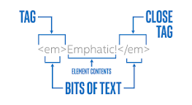
* **HTML tag is just opening or closing entity**. For example: <p> and </p> are called HTML tags. HTML element encompasses opening tag, closing tag, content (optional for content-less tags) Eg: <p>This is the content</p> : This complete thing is called a HTML element
* An **HTML element** is defined by a start tag, some content, and an end tag. **HTML Elements**. The **HTML element** is everything from the start tag to the end tag: